1. The Underwater Swimming Manipulator—A Bioinspired Solution for Subsea Operations

underwater swimming manipulator (USM):

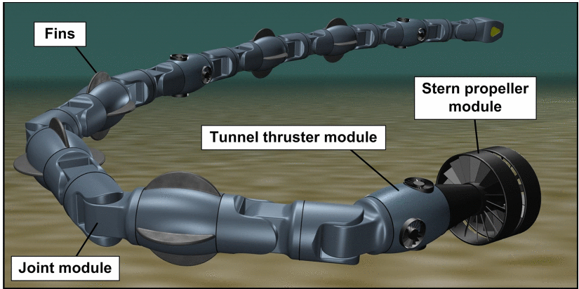

it provides compact matrix expressions, easy implementation, and a flexibility that accommodates an arbitrary number of links, with variable link length, and free choice of the base of the USM;

study motion coordination of the joints and the base of the USM;

The comparison part:

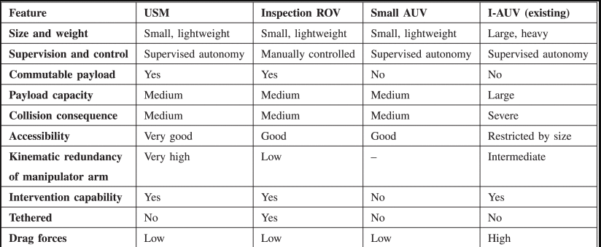

Reference frame:

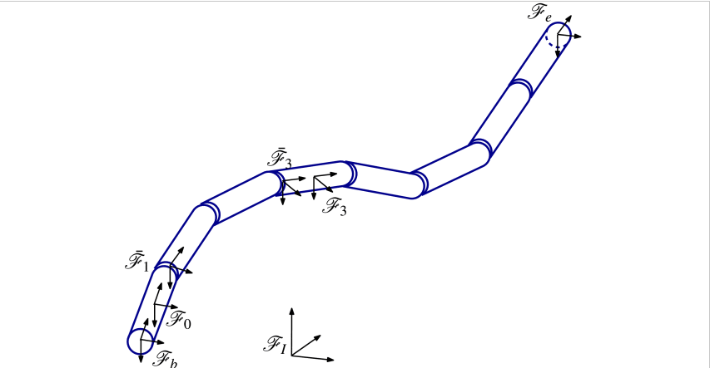

1. A review of manipulator

